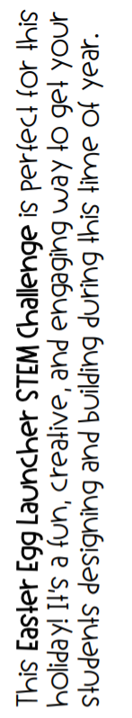
Easter egg launcher - Makerspace
Your Task : Design and build an egg launcher for Easter eggs using skewers (wooden sticks), rubber bands, clothespins and a piece of fabric. You can add 2 other items of your choice (tape/glue/foil etc.)
Your Challenge : See how far your egg will travel. Try with different types of eggs (plastic, chocolate, wooden). DON’T USE REAL EGGS!!! That’s wasting and they’re too messy.
Your Success: Take a video or pictures and send them to me at Michael.grant@nbed.nb.ca.
Tell me about your project and look for them on Instagram and the website.
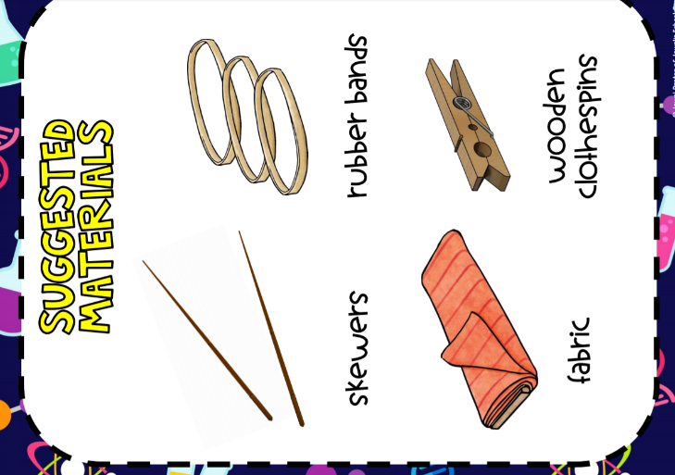
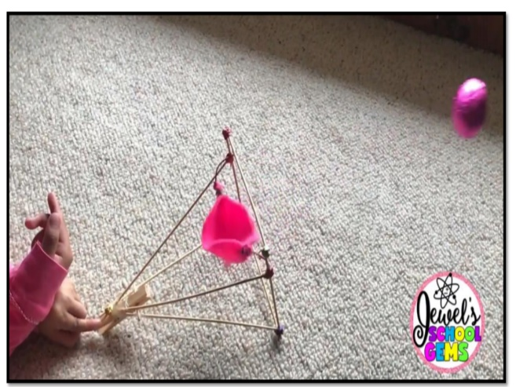
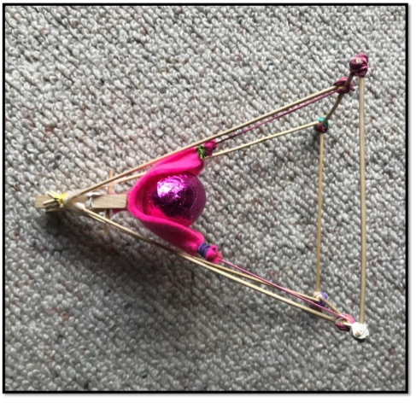
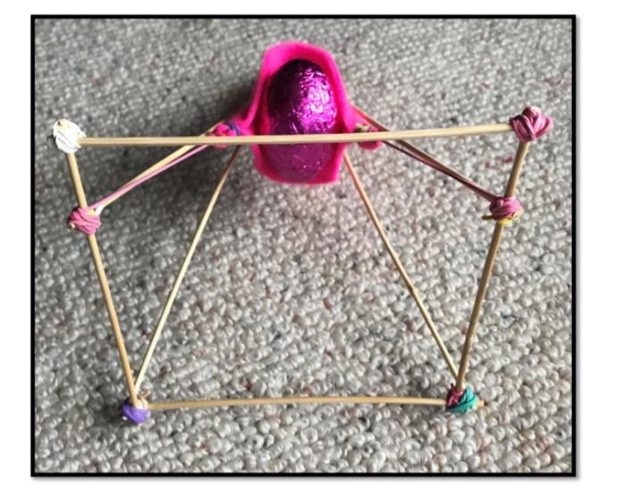
IDEAS see it in action : https://www.youtube.com/watch?v=xKGzqR1Josk&feature=youtu.be

